Appendix A Public Involvement / Participation
The GWMP’s stormwater webpage was updated to includes the following information:
- Effective MS4 permit and coverage letter
- Most current MS4 Program Plan
- Annual report within 30 days of submittal to DEQ
- List of GWMP staff and phone numbers for the public to contact
- TMDL reports
- SWPPP
- MS4 maps
- Training materials
- Comment button to allow for the public to submit comments/concerns to GWMP

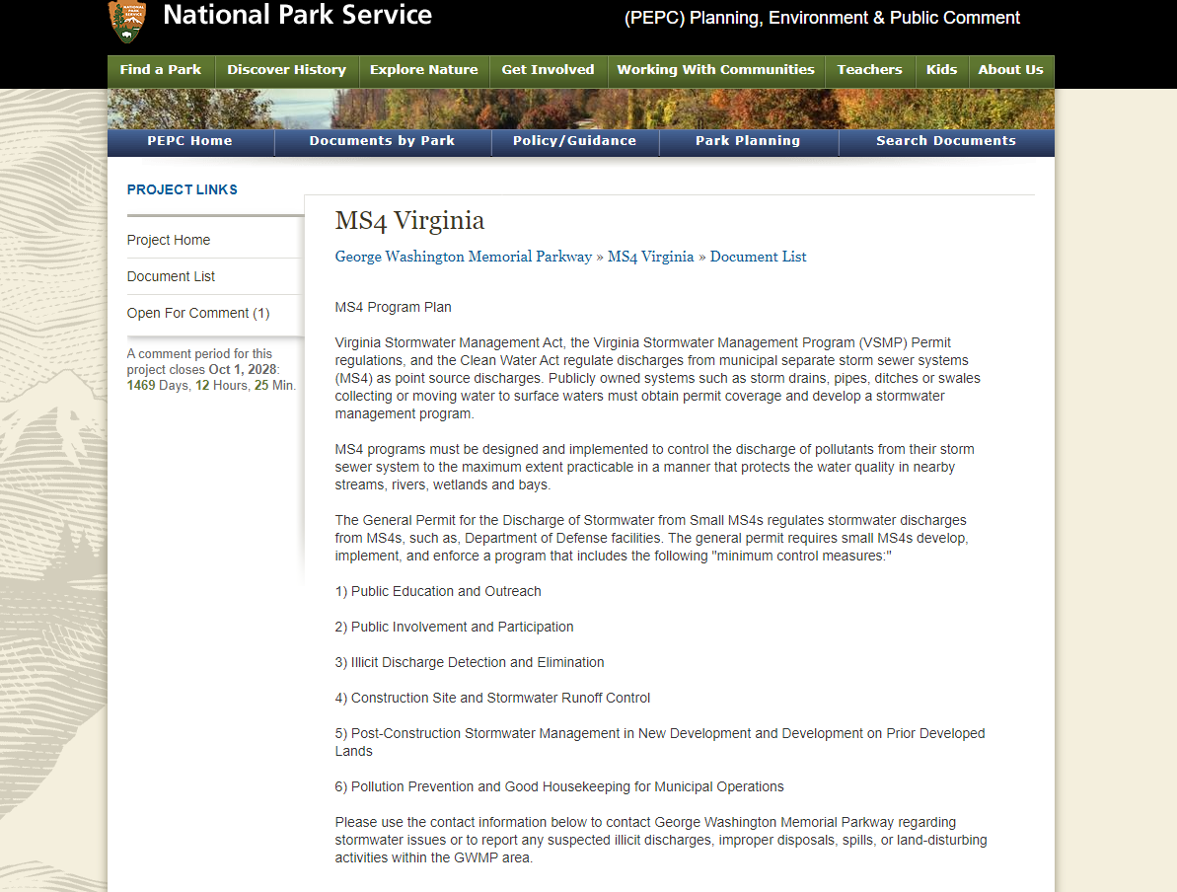
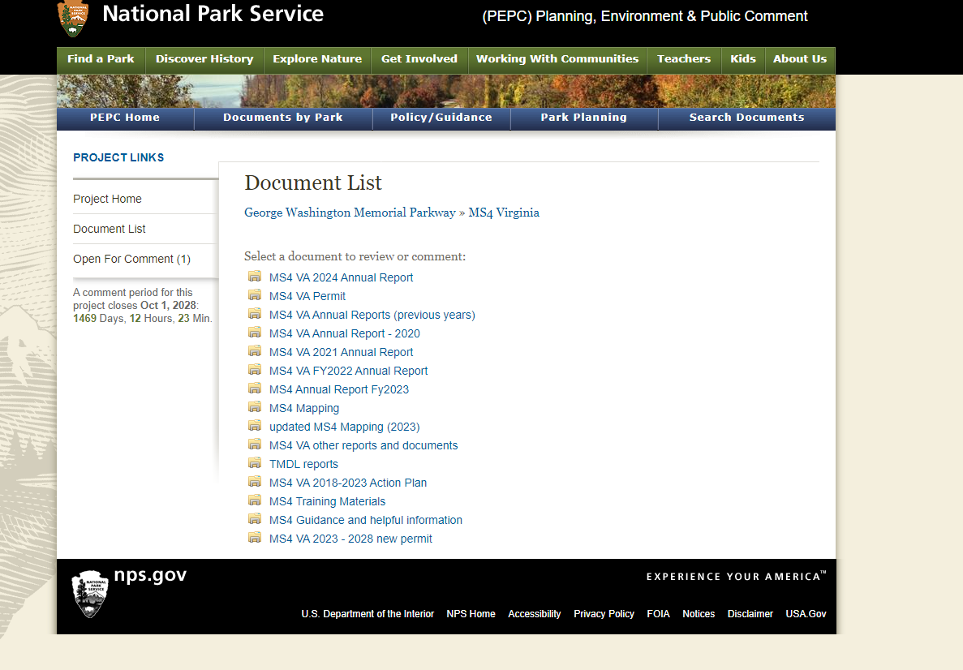

Appendix B Illicit Discharge Detection and Elimination

Daingerfield SWPPP checklist:
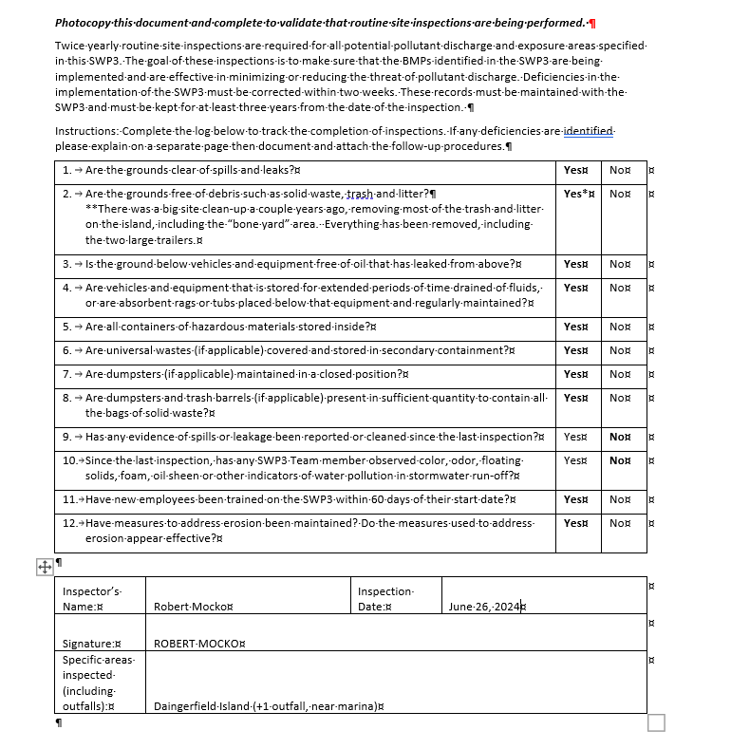

Maintenance Yard SWPPP Checklist

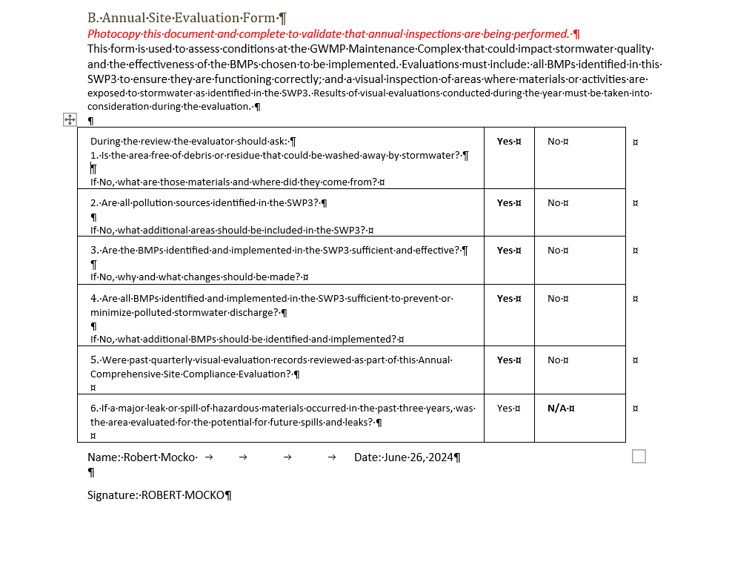

FY2024 Outfall Inspection:

