Big Cypress National Preserve
Map 26-001
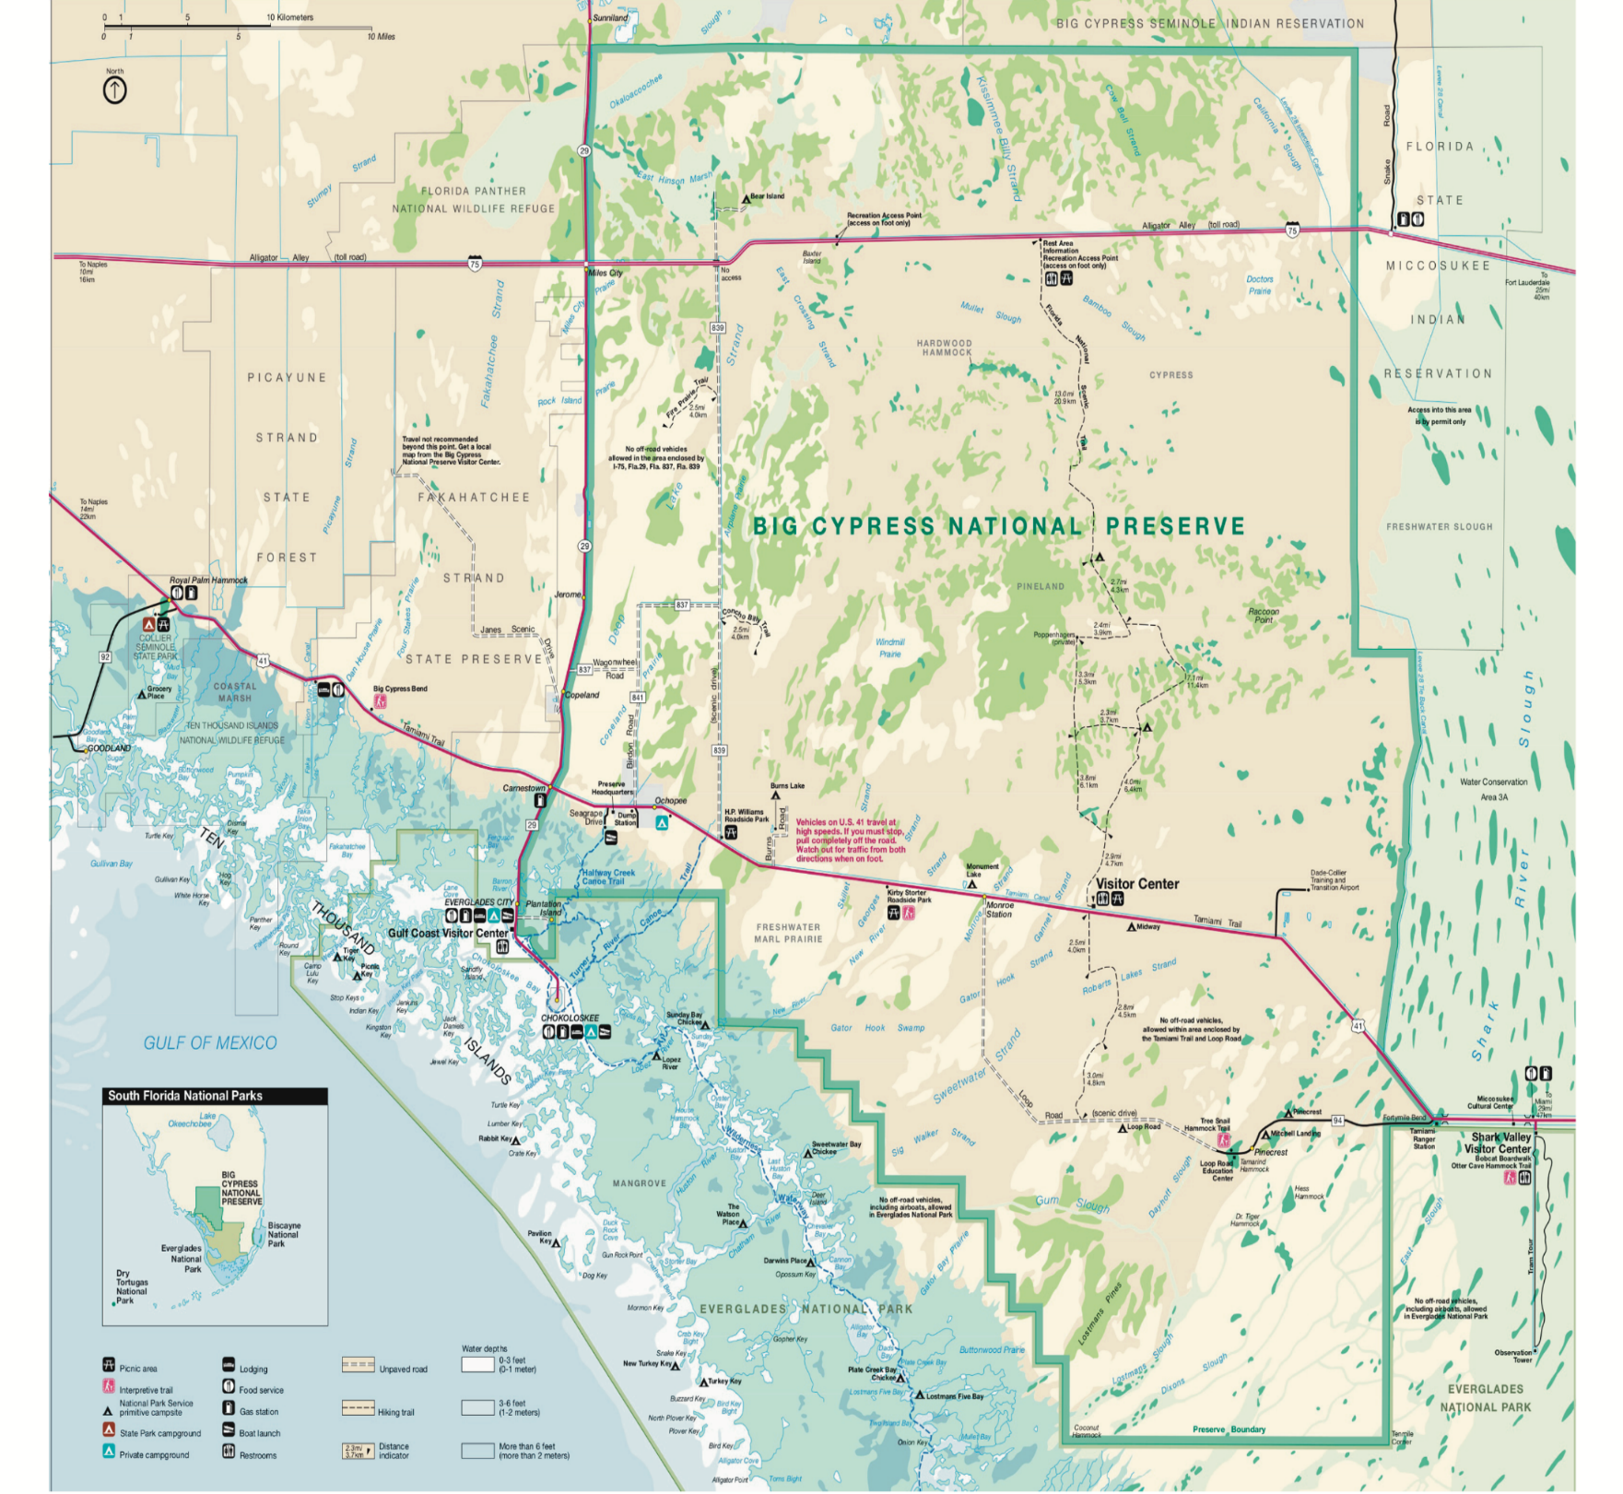
May 1, 2026

